The Untold Accessibility Story: How Publishers Are Doing More Than They're Saying

A Post-EAA Survey of Publisher Accessibility Statements

Prepared by ASPIRE | January 2026

Introduction
You'd never publish a book without marketing copy. So why implement accessibility work and not tell anyone?
This quote is taken from European Accessibility Act + accessibility statements: An ASPIRE overview (October 2024), an ASPIRE Paper written in the months leading up to the implementation of the European Accessibility Act.
The EAA came into force on 28 June 2025, requiring publishers to provide accessibility information to users. But the EAA doesn't specify how — there's no template, no prescribed format. This freedom is an opportunity: accessibility statements can tell the story of your work, your values, and your investment.
We reviewed the accessibility statements of 25 major publishers to understand how the industry is communicating with users post-EAA. Using 5 key indicators derived from ASPIRE criteria and a series of qualitative measures (including GCA-certification and PAAG Charter commitment), we evaluated how effectively publishers are telling their accessibility story.
What we found was an opportunity gap: publishers are doing more accessibility work than they're communicating. Their story isn't being told.
This isn't about compliance failures. It's about missed opportunities:
- Publishers with Benetech Global Certified Accessible (GCA) certification who barely mention it.
- PAAG Accessible Publishing Charter signatories who don't reference their membership and commitment.
- Image description workflows that are not communicated to users and readers.
- Comprehensive accessibility programmes hidden behind minimal public statements.

The accessible publishing work is being done. Users just can't discover it.

What We Found: The Opportunity Gap
The survey uncovered the following elements:

The good news
- 96% of publishers surveyed have some form of accessibility statement or information.
- 52% of publishers surveyed are PAAG Charter signatories — demonstrating industry commitment.
- 40% hold Benetech GCA certification for born-accessible ebook production.
- 1 publisher achieved a perfect score across all indicators.

The opportunity
- Overall, publishers are communicating 50% of their potential accessibility story — leaving half untold.
- 56% don't mention image descriptions at all in their accessibility statements.
- 68% don't date their statements — missing a chance to demonstrate currency and engagement.
- Despite their certified production capabilities, GCA-certified publishers score only marginally higher on communication indicators (5.7 vs 5.4 out of 11).
- We found GCA-certified publishers at both extremes of our scoring range.
- One major publisher has no accessibility statement at all.

The gap between what publishers are achieving and what they're communicating represents unrealised value — both for users who can't discover accessible content, and for publishers who aren't getting credit for their investment.

What Does Excellence Look Like?
The following chart compares indicator performance across the scoring spectrum — from the top-performing publishers to those at the bottom of our survey.

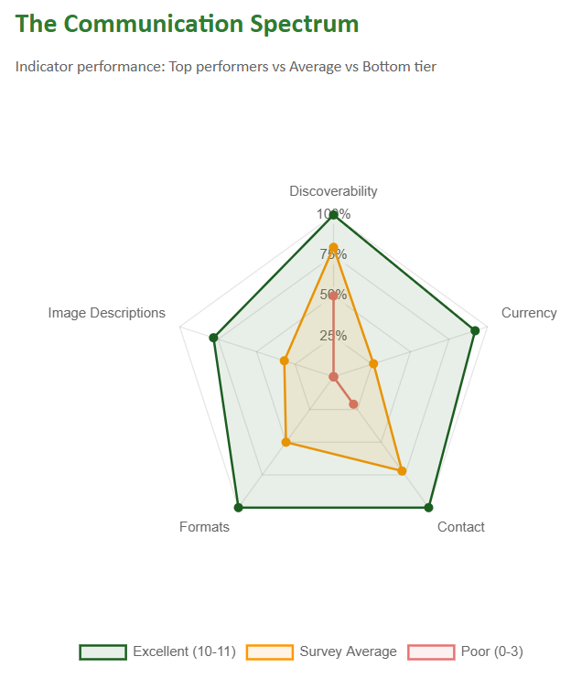
The top-ranked publishers in our survey demonstrate what's possible when accessibility communication is treated as an opportunity rather than an obligation. Their statements include:
- Specific commitments: "All new ebook titles include alt text for images."
- Clear format information: EPUB3, PDF, alternative format request processes with response times.
- Named contacts with specific accessibility roles.
- Platform documentation with VPATs/ACRs available.
- Certifications prominently displayed (Benetech GCA, where held).
- Charter memberships referenced (PAAG, ABC).
- Regular updates with visible dates.
- A roadmap for ongoing work — backlist remediation, future improvements.

These statements tell a story. They demonstrate investment, commitment, and respect for users. They're marketing copy for accessibility work — and they're exactly what the EAA envisions.

The Survey Results
We reviewed 25 major publishers against 5 indicators derived from ASPIRE criteria.
- Discoverability: the ease of discoverability of accessibility information on the website.
- Currency: the date of the most recent update of the statement.
- Contact: level of contact information provided.
- Formats: the formats available for users.
- Image Descriptions: the provision of alt text in publisher titles.
The maximum possible score is 11 points.

Score distribution
Score Range | Publisher Count | Description
10–11 (Excellent) | 6 | Comprehensive, user-focused statements
8–9 (Good) | 1 | Solid foundation with minor gaps
6–7 (Moderate) | 4 | Basic information present, opportunities to improve
4–5 (Limited) | 7 | Significant gaps in communication
0–3 (Poor) | 7 | Minimal or absent accessibility communication

Indicator performance
Indicator | Max Score | Average Score | % Achieved
Discoverability | 2 | 1.60 | 80%
Currency | 2 | 0.52 | 26%
Contact | 2 | 1.44 | 72%
Formats | 2 | 1.00 | 50%
Image Descriptions | 3 | 0.96 | 32%

Discoverability (80%) and Contact (72%) are the strongest indicators. Currency and Image Descriptions are the weakest, achieving just 26% and 32% of maximum points respectively — representing the clearest opportunities for improvement.

Patterns We Observed
1. ASPIRE review helps publishers tell their story
Four publishers in this survey have previously undergone ASPIRE review and achieved Gold certification. While it's unsurprising that publishers who engaged with the ASPIRE process perform well against ASPIRE criteria, their results demonstrate what focused attention on accessibility communication can achieve:
Group | Average Score | Percentage
ASPIRE Gold (4) | 10.0/11 | 91%
All other publishers (21) | 4.7/11 | 42%

The value of ASPIRE review lies in the process itself: a structured assessment that identifies gaps, provides specific recommendations, and helps publishers communicate their accessibility work effectively. The results show what's achievable when publishers invest in their accessibility statements.
The improvement is consistent across all five indicators:
Indicator | ASPIRE Gold | Others | Gap
Discoverability | 100% | 76% | +24
Currency | 75% | 17% | +58
Contact | 100% | 67% | +33
Formats | 100% | 40% | +60
Image Descriptions | 83% | 22% | +61

This difference is visible across all five indicators:
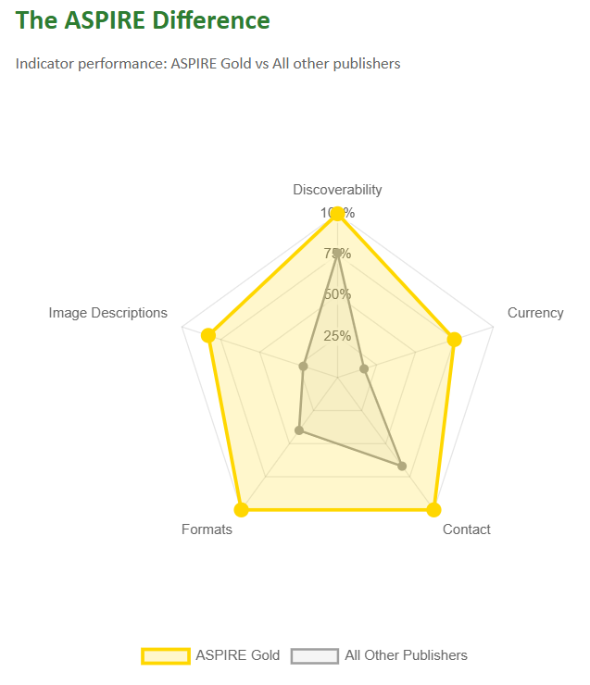

One ASPIRE Gold publisher holds neither PAAG membership nor GCA certification — demonstrating that excellence in accessibility communication is achievable through focused attention on the statement itself, independent of other industry affiliations.
2. The capability vs communication gap
GCA certification demonstrates that a publisher has implemented born-accessible ebook workflows. Yet despite this certified capability, GCA-certified publishers score only marginally higher on our communication indicators (5.7 vs 5.4 out of 11).
We found GCA-certified publishers at both extremes of our scoring range — reinforcing that production capability and communication transparency are independent variables. A publisher can have world-class accessible production workflows while providing users with almost no information about those capabilities.
3. PAAG membership correlates with transparency
PAAG Charter signatories score significantly higher on average (7.3 vs 3.6 out of 11). The Charter's focus on embedding accessibility across the publishing ecosystem appears to translate into better communication practices.
However, membership alone doesn't guarantee good communication. Two PAAG signatories score 4 or below, suggesting the Charter's commitments aren't yet consistently reflected in public statements.
When we examine the interaction between PAAG and GCA status, the pattern becomes clearer:
 | GCA | No GCA
PAAG | 7.3 (6) | 7.3 (7)
No PAAG | 3.2 (4) | 3.8 (8)

Average scores out of 11, with publisher count in brackets.
PAAG membership appears to be a stronger predictor of communication quality than GCA certification. Publishers with PAAG membership average around 7/11 regardless of GCA status, while those without PAAG average around 3.5/11 — even when GCA-certified.
4. Academic/STM publishers lead the way
Academic/STM/Professional publishers outperform the Trade sector:
Sector | Average Score | Percentage | Score Range
Academic/STM/Professional (17) | 6.3/11 | 57% | 0–11
Trade (8) | 3.9/11 | 35% | 1–10
All publishers (25) | 5.5/11 | 50% | 0–11

5 of the 6 top-scoring publishers are in the Academic/STM/Professional sector. This may reflect closer engagement with institutional accessibility requirements and research community needs.
5. Image descriptions: the hidden investment
56% of publishers don't mention image descriptions at all — and some of those that do provide only vague statements rather than specific commitments. This explains why publishers achieved only 32% of possible points on this indicator. Yet industry conversations suggest far more publishers have implemented alt text workflows, trained authors, or are actively remediating backlists.
The sector divide is stark. Academic/STM/Professional publishers average 43% on image description communication, with 59% mentioning the topic. Trade publishers average just 8%, with only 1 in 8 mentioning image descriptions at all.

Sector | Average (of 3) | % Mentioning
Academic/STM/Professional (17) | 1.29 (43%) | 59%
Trade (8) | 0.25 (8%) | 12%

Perhaps the most striking finding concerns GCA-certified publishers. Despite having certified born-accessible production workflows — which include image description requirements — 60% of GCA publishers don't mention image descriptions in their accessibility statements. GCA certification appears to have no positive correlation with communicating about image descriptions:
 | GCA | No GCA
PAAG | 50% | 57%
No PAAG | 25% | 38%

Percentage of publishers mentioning image descriptions.
This is precisely the kind of information users need. A simple statement — "Our ebooks include alternative text for images" — would significantly improve many accessibility statements. For GCA-certified publishers already doing this work, the communication gap represents a significant missed opportunity.
6. Undated statements undermine trust
68% of publishers don't date their accessibility statements. An undated statement leaves users wondering: is this current policy, or something from 2019? Dating a statement takes seconds and immediately signals thoughtful engagement.
Only 20% of publishers have a statement dated within the last 12 months. A further 12% have dates, but they're over a year old — suggesting statements that were created and then forgotten.
Sector | Recent | Old | Undated
Academic/STM/Professional (17) | 24% | 12% | 65%
Trade (8) | 12% | 12% | 75%

Recent = dated within 12 months. Old = dated but over 12 months ago.
The correlation with PAAG membership is striking. Every single publisher with a recently dated statement is a PAAG signatory. Among non-PAAG publishers, not one has a current date on their accessibility statement:

 | GCA | No GCA
PAAG | 50% | 29%
No PAAG | 0% | 0%

Percentage of publishers with statements dated within 12 months.
GCA-only publishers — those with certification but without PAAG membership — have a 100% undated rate. This reinforces the broader pattern: GCA certification, while valuable for production quality, does not appear to influence communication practices. PAAG membership is the differentiating factor.

Understanding the landscape
GCA certification demonstrates commitment to producing accessible content — the technical foundation that makes accessibility possible. PAAG membership signals commitment to embedding accessibility principles across the publishing ecosystem. ASPIRE review helps publishers communicate that work effectively to users.

Each serves a different purpose. None is a substitute for the others. And none of them is the end goal.

The end goal is the reader: someone who can discover what's available, understand what to expect, and access the content they need. Certifications and memberships are means to that end — valuable signals of commitment, but only valuable if they translate into a better reader experience.

The best accessibility statements we reviewed understand this. They don't just list credentials — they speak directly to users about what they'll find and how to get help. That's the untold story this report is asking publishers to tell.

The flow from certification to communication
The diagram below shows how publishers with different certifications and memberships performed in our survey. Each flow represents publishers moving from their starting point (left) to their communication score band (right).

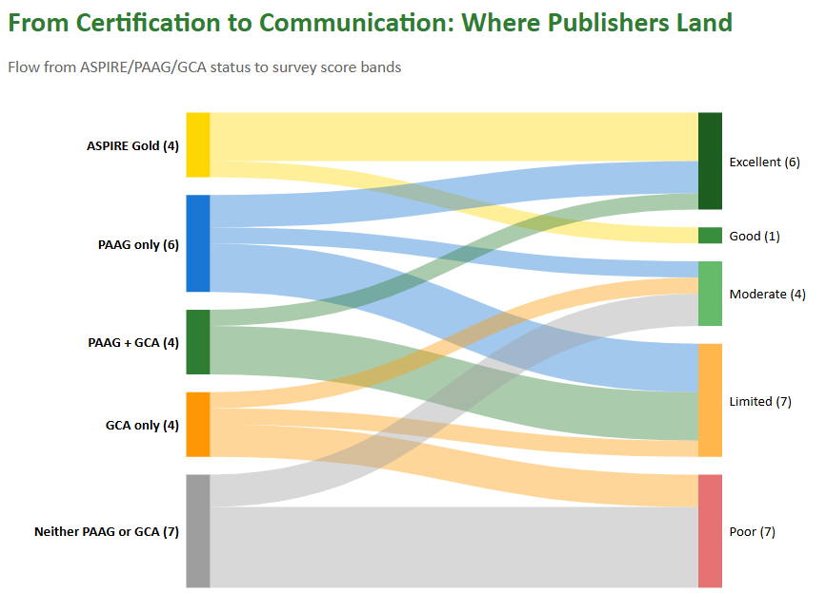
The patterns are striking:
- ASPIRE Gold publishers flow exclusively to Excellent and Good — none fall below.
- PAAG members (with or without GCA) reach Excellent, but some fall to Limited — membership helps, but doesn't guarantee strong communication.
- GCA-only publishers never reach Excellent or Good — certified production capability alone doesn't translate to communication quality.
- Publishers with neither cluster at Moderate and Poor.
The visual reinforces what the data shows: production certification (GCA) and communication quality are independent variables. PAAG membership correlates with better outcomes. ASPIRE review delivers consistent results.

8 Elements your accessibility statement should include
Based on EAA requirements, ASPIRE criteria, and best practice observed in our survey:
- Content accessibility information. Not just platform or website accessibility. Tell users about the actual books, journals, and learning materials.
- Image description policy. Do your ebooks include alt text? Since when? For what proportion of titles? Be specific.
- Available formats. EPUB3, PDF, audio, braille partnerships? What can users request? How long does it take?
- A date. When was this statement last updated? Currency builds trust.
- A dedicated contact. An accessibility-specific email or named person, not just a generic contact form.
- Standards and certifications. WCAG conformance, EPUB Accessibility Specifications, Benetech GCA — if you've earned it, display it.
- Memberships and commitments. PAAG Charter, ABC Charter, DAISY partnership. These signal commitment to users and the industry.
- Honest limitations and a roadmap. What are you still working on? What's coming next? Transparency builds trust more than claims of perfection.

The ASPIRE Philosophy
ASPIRE measures communication, not capability. We've always believed that telling users what to expect is itself an accessibility feature.
An accessibility statement is an ongoing dialogue with your readers and users. It offers you the opportunity to say, "We're doing X because of Y." It's a transparent, honest, practical, user-friendly document that reaches your whole audience.
This survey reinforces that belief. The gap we've identified isn't in what publishers are doing — it's in what users can discover. That 50% untold story represents significant unrealised value. Publishers have great stories to tell. Many just aren't telling them yet.
This is all carrot, no stick. We want publishers to succeed. The EAA provides the framework; your accessibility statement provides the opportunity. Let it tell your story.

How ASPIRE Can Help
ASPIRE provides expert assessment of publisher and platform accessibility statements. You'll receive a comprehensive report with recommended enhancements, helping you communicate your accessibility work effectively to users.
The review process is confidential. Our goal is to help you tell your accessibility story — not to criticise. We provide the criteria upfront; there are no surprises.
We've helped publishers and platforms across the industry create and refine their accessibility statements.
Contact textBOX about an ASPIRE review: aspire@textboxdigital.com
Learn more about the ASPIRE review process: www.textboxdigital.com/aspire-home

Methodology
This survey assessed 25 major publishers against 5 key ASPIRE indicators. Publishers were selected from English-language academic/STM/professional and trade publishing sectors.
Each publisher was assessed based solely on the content of their designated accessibility statement page. Information not present on that page was not credited, reflecting the user experience of someone seeking accessibility information.
Scored indicators (11 points total)
Indicator | Max | Scoring criteria
Discoverability | 2 | 2 = Easy to find, dedicated page | 1 = Exists but difficult to find | 0 = Not found
Currency | 2 | 2 = Dated within 12 months | 1 = Dated more than 12 months ago | 0 = No date
Contact | 2 | 2 = Dedicated email or named person | 1 = Form or generic contact | 0 = None
Formats | 2 | 2 = Formats listed with detail | 1 = Formats mentioned | 0 = No information
Image Descriptions | 3 | 3 = Specific commitment | 2 = General mention | 1 = Planned/partial | 0 = Not mentioned

Qualitative observations
Additional observations were recorded for GCA certification status, PAAG Charter signatory status, and ASPIRE Gold certification. These inform the narrative findings.
Results were cross-referenced against the PAAG Charter signatory list and Benetech GCA certified publisher list to identify gaps between achievement and communication.
All accessibility statements were assessed on 22 January 2026. Any subsequent changes to publisher statements are not reflected in this survey.

Publisher identities have been anonymised. The purpose of this survey is to identify industry patterns and opportunities, not to criticise individual organisations.

───────────────────────────────────
Survey conducted January 2026 by ASPIRE and textBOX
www.textboxdigital.com

ASPIRE Report: Image Descriptions Annex
The following descriptions are provided as an accessibility annex to accompany The Untold Accessibility Story: How Publishers Are Doing More Than They're Saying.

Figure 1: The Communication Spectrum
ALT TEXT
A radar chart compares indicator performance across 3 groups of publishers: the Excellent tier, the Survey Average, and the Poor tier.

LONG DESCRIPTION
The description of the radar chart is presented in 4 main sections as follows.
Section 1. Context.
The chart illustrates the performance gap between the highest-scoring and lowest-scoring publishers in the ASPIRE survey, with the survey average shown for comparison. The visualisation demonstrates what excellence looks like across the 5 ASPIRE indicators, and how significantly the poorest performers fall short. The Excellent tier comprises the 6 publishers scoring 10 or 11 out of 11. The Poor tier comprises the 7 publishers scoring 3 or below.
Section 2. Structure.
The radar chart has 5 spokes radiating from the centre, each representing one of the ASPIRE indicators. The spokes are labelled Contact, Currency, Discoverability, Formats, and Image Descriptions. All axes share the same percentage scale, marked at 25 per cent, 50 per cent, 75 per cent, and 100 per cent from the centre outward.
Three polygons are plotted on the chart. The Excellent tier is shown in green with a light green fill. The Survey Average is shown in orange with a light orange fill. The Poor tier is shown in red with no fill. A legend below the chart identifies each group: Excellent as scores of 10 to 11, Survey Average, and Poor as scores of 0 to 3.
Section 3. Walkthrough.
The 3 shapes tell a striking story of divergence as follows.
- Excellent. The Excellent tier polygon nearly fills the chart, forming a large, well-balanced shape. It achieves 100 per cent on 3 indicators: Discoverability, Contact, and Formats. Currency reaches 92 per cent, and Image Descriptions, at 78 per cent, represents the only notable gap from the outer edge.
- Average. The Survey Average polygon is considerably smaller and more irregular. Discoverability remains strong at 80 per cent, and Contact holds at 72 per cent. However, the shape collapses inward on the remaining 3 indicators: Formats drops to 50 per cent, Image Descriptions to 32 per cent, and Currency to just 26 per cent.
- Poor. The Poor tier polygon is dramatically smaller, hugging the centre of the chart. Discoverability reaches only 50 per cent, Contact falls to 21 per cent, and the remaining three indicators, Currency, Formats, and Image Descriptions, all score zero. The shape is essentially a small wedge pointing toward Discoverability, with nothing extending toward the other axes.
The visual contrast between the expansive green polygon and the collapsed red shape illustrates the scale of the opportunity gap identified in the survey.
Section 4. Data.
The data are presented in the following table, ordered clockwise from 12 o'clock.
Indicator | Excellent (10–11) | Survey Average | Poor (0–3)
Discoverability | 100% | 80% | 50%
Currency | 92% | 26% | 0%
Contact | 100% | 72% | 21%
Formats | 100% | 50% | 0%
Image Descriptions | 78% | 32% | 0%

Description ends.

Figure 2: The ASPIRE Difference
ALT TEXT
A radar chart compares indicator performance between ASPIRE Gold publishers and all other publishers in the survey.

LONG DESCRIPTION
The description of the radar chart is presented in 4 main sections as follows.
Section 1. Context.
The chart demonstrates the difference in accessibility communication between publishers who have undergone ASPIRE review and achieved Gold certification compared with the remaining publishers in the survey. Four publishers hold ASPIRE Gold status. The remaining 21 publishers form the comparison group.
Section 2. Structure.
The radar chart has 5 spokes radiating from the centre, each representing one of the ASPIRE indicators. The spokes are labelled Contact, Currency, Discoverability, Formats, and Image Descriptions. All axes share the same percentage scale, marked at 25 per cent, 50 per cent, 75 per cent, and 100 per cent from the centre outward.
Two polygons are plotted on the chart. ASPIRE Gold is shown in gold with a light-yellow fill. All Other Publishers is shown in grey with no fill. A legend below the chart identifies each group.
Section 3. Walkthrough.
The two shapes reveal a substantial performance gap across all five indicators.
The ASPIRE Gold polygon dominates the chart, forming a large, well-balanced shape that extends close to the outer edge on most axes. It achieves 100 per cent on Discoverability, Contact, and Formats. Image Descriptions reaches 83 per cent, and Currency, at 75 per cent, represents the only notable shortfall from perfection.
The All Other Publishers polygon is considerably smaller and more irregular. Discoverability is the strongest indicator at 76 per cent, with Contact at 67 per cent. The shape then contracts sharply: Formats falls to 40 per cent, Image Descriptions to 22 per cent, and Currency to just 17 per cent.
The gap between the two groups is most pronounced on 3 indicators. Formats shows a 60 percentage point difference. Image Descriptions shows a 61 percentage point difference. Currency shows a 58 percentage point difference. Even on the stronger indicators, Discoverability and Contact, the ASPIRE Gold group leads by 24 and 33 percentage points respectively.
The consistent outperformance across all five dimensions demonstrates the impact of focused attention on accessibility communication.
Section 4. Data.
The data are presented in the following table, ordered clockwise from 12 o'clock. A variance column shows the percentage point difference between ASPIRE Gold and All Others.
Indicator | ASPIRE Gold | All Others | Variance
Discoverability | 100% | 76% | +24
Currency | 75% | 17% | +58
Contact | 100% | 67% | +33
Formats | 100% | 40% | +60
Image Descriptions | 83% | 22% | +61

Description ends.

Figure 3: From Certification to Communication: Where Publishers Land
ALT TEXT
A Sankey diagram illustrates how publishers flow from their certification and membership status to their survey score bands.

LONG DESCRIPTION
The description of the Sankey diagram is presented in 3 main sections as follows.
Section 1. Context.
The diagram illustrates the relationship between publisher credentials and communication outcomes in the ASPIRE survey. It traces 25 publishers from their starting position, defined by their ASPIRE, PAAG, and GCA status, to their final score band. The visualisation reveals which credentials correlate with strong accessibility communication and which do not.
Section 2. Structure.
A Sankey diagram displays quantitative flows between two or more parallel sets of categories. Categories are displayed as stacked bars or nodes, with curved bands connecting them. The thickness of each band is proportional to the quantity flowing between categories.
The diagram flows from left to right. On the left side are 5 source categories representing certification and membership status: ASPIRE Gold with 4 publishers, shown in gold; PAAG only with 6 publishers, shown in blue; PAAG plus GCA with 4 publishers, shown in green; GCA only with 4 publishers, shown in orange; and Neither PAAG or GCA with 7 publishers, shown in grey.
On the right side are 5 destination categories representing survey score bands: Excellent with 6 publishers; Good with 1 publisher; Moderate with 4 publishers; Limited with 7 publishers; and Poor with 7 publishers.
Curved bands connect each source to its destinations, with band thickness proportional to the number of publishers in each flow.
Section 3. Walkthrough.
Key patterns.
The diagram reveals 3 striking findings. First, ASPIRE Gold is the only credential that guarantees a path to the top tiers; all four publishers reach Excellent or Good. Second, GCA certification alone shows no path to Excellent or Good; certified production capability does not translate to communication quality. Third, PAAG membership correlates with reaching Excellent, but does not guarantee it; PAAG members appear across all score bands except Poor.
Due to the complexity of this diagram, the data are presented in 2 levels of analysis: first, a summary of flows by source category, and second, the full flow matrix showing every source-destination pair.
Summary by source category.
- ASPIRE Gold publishers flow exclusively to the top two score bands. Three reach Excellent and one reaches Good. None fall below Good.
- PAAG only publishers show mixed outcomes. Two reach Excellent, one lands in Moderate, and three fall to Limited.
- PAAG plus GCA publishers divide sharply. One reaches Excellent, but three fall directly to Limited, with nothing in between.
- GCA only publishers flow entirely to the lower bands. One reaches Moderate, one lands in Limited, and two fall to Poor. None reach Excellent or Good.
- Neither PAAG or GCA publishers cluster at the bottom. Two reach Moderate, but five flow to Poor.
Full flow matrix.
The following tables present the complete flows from each source category.
ASPIRE Gold to score bands (4 publishers):
Destination | Count
Excellent | 3
Good | 1

PAAG only to score bands (6 publishers):
Destination | Count
Excellent | 2
Moderate | 1
Limited | 3

PAAG plus GCA to score bands (4 publishers):
Destination | Count
Excellent | 1
Limited | 3

GCA only to score bands (4 publishers):
Destination | Count
Moderate | 1
Limited | 1
Poor | 2

Neither PAAG or GCA to score bands (7 publishers):
Destination | Count
Moderate | 2
Poor | 5

Description ends.

